

Semester Two Examination, 2020

Question/Answer booklet

MATHEMATICS METHODS
UNIT 1 AND 2

Section Two:

Calculator-assumed

Name: SOLUTIONS

Teacher’s Name:_______________________________________________

Time allowed for this section
Reading time before commencing work: ten minutes
Working time: one hundred minutes

Materials required/recommended for this section
To be provided by the supervisor
This Question/Answer booklet
Formula sheet (retained from Section One)

To be provided by the candidate
Standard items: pens (blue/black preferred), pencils (including coloured), sharpener, correction fluid/tape, eraser, ruler, highlighters

Special items: drawing instruments, templates, notes on two unfolded sheets of A4 paper, and up to three calculators approved for use in this examination

Important note to candidates
No other items may be taken into the examination room. It is your responsibility to ensure that you do not have any unauthorised material. If you have any unauthorised material with you, hand it to the supervisor before reading any further.

Question | Marks | Max | Question | Marks | Max
10 |  | 4 | 18 |  | 9
11 |  | 10 | 19 |  | 8
12 |  | 4 | 20 |  | 4
13 |  | 3 | 21 |  | 4
14 |  | 5 | 22 |  | 8
15 |  | 4 | 23 |  | 6
16 |  | 4
17 |  | 12
Structure of this paper

Section | Number of questions available | Number of questions to be answered | Working time (minutes) | Marks available | Percentage of examination
Section One:  Calculator-free | 9 | 9 | 50 | 44 | 34
Section Two:  Calculator-assumed | 14 | 14 | 100 | 85 | 66
 |  |  |  | Total | 100
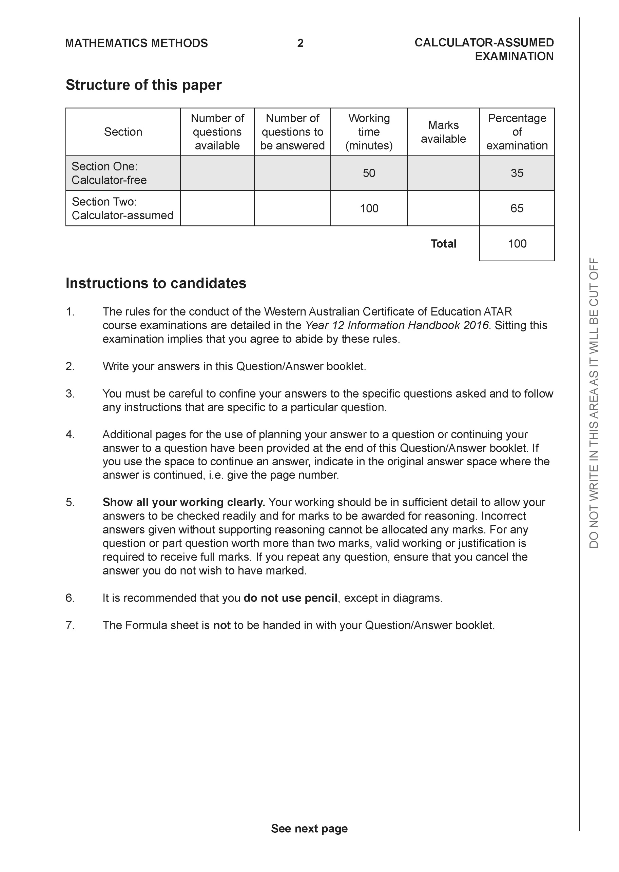

Section Two: Calculator-assumed (85 Marks)

This section has 14 questions. Answer all questions. Write your answers in the spaces provided.

Spare pages are included at the end of this booklet. They can be used for planning your responses and/or as additional space if required to continue an answer.
● Planning: If you use the spare pages for planning, indicate this clearly at the top of the page.
● Continuing an answer: If you need to use the space to continue an answer, indicate in the original answer space where the answer is continued, i.e. give the page number. Fill in the number of the question that you are continuing to answer at the top of the page.

Working time: 100 minutes.

Question 10 {1.1.28} (4 marks)
Apply the vertical line test to each of the following graphs and conclude whether the graph represents a relation or a function.

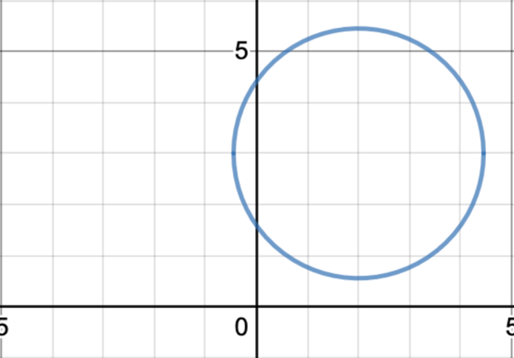
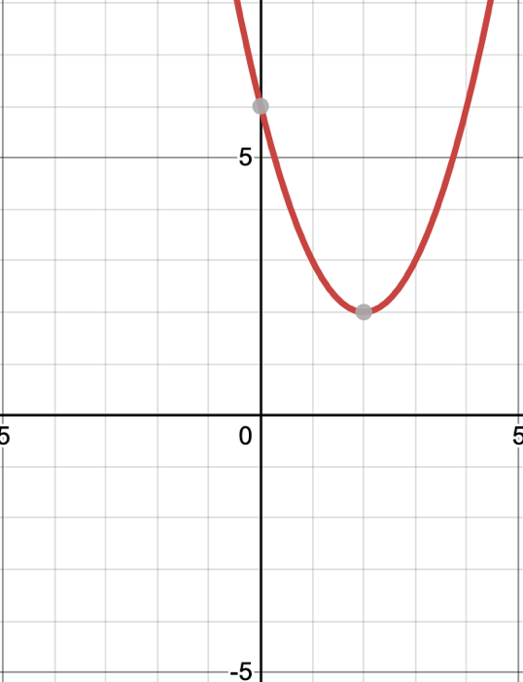

- ____________FUNCTION b) RELATION

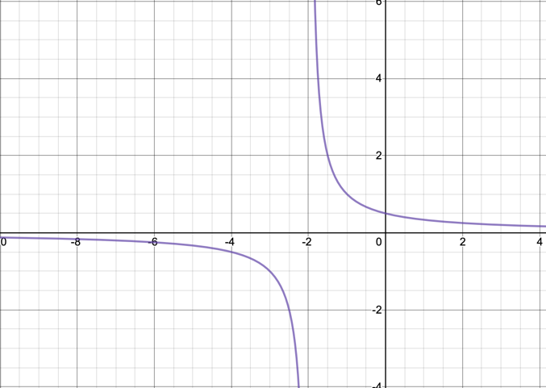
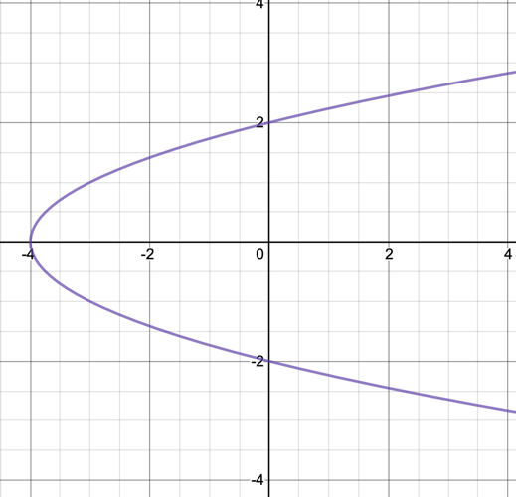

- ___ RELATION d) FUNCTION

Question 11 (1.1.1 – 1.1.6) (2, 2, 1, 3, 2 = 10 marks)
The kite ABCD is graphed below.
The coordinates of the vertices are A(2, 5), B(4, 6), C(5,4) and D(x, 0) as shown below.
NB Kites have diagonals that meet at right angles.

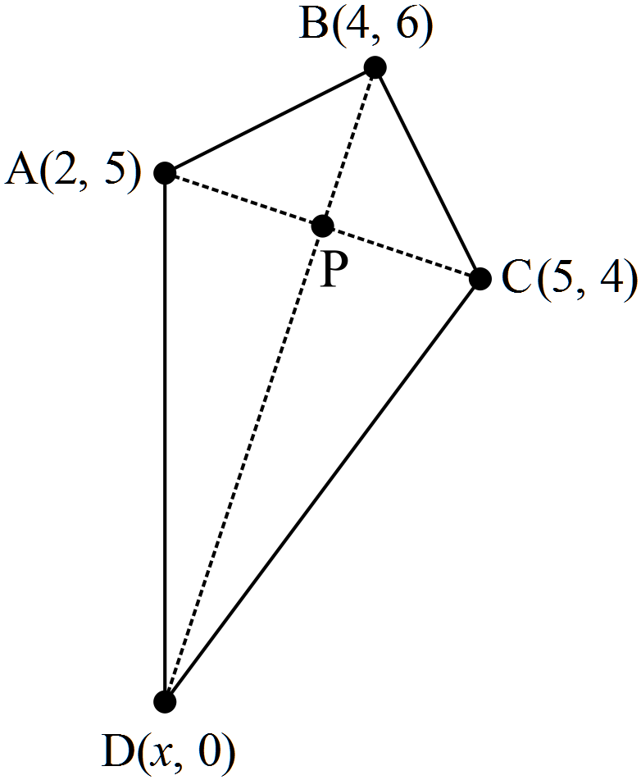

(a) Show that AB = BC.

(b) Find the gradient of AC and hence the equation of the diagonal BD.

(c) Determine the value of d, the x co-ordinate of point D.

(d) Find the midpoint of AC and show it belongs to diagonal BD.

(e) Show how the midpoint of AC could have been used to determine the
value of

Question 12 {1.1.26} (4 marks)

- Give the equation of the image $y=x^{2}$ after the following transformation:
Translate 3 units horizontally left followed by reflection in the $x$-axis.

Solution
$$y=-{\left(x+3\right)}^{2}$$

Specific behaviours
+ 3
Applies negative to the whole function

- Give the equation of the image $y=\frac{1}{x}$ after the following transformation:
Translate vertically up 2 units then reflect in the $y$-axis.

Solution
$$y= -\frac{1}{x}+2$$

Specific behaviours
+ 2
Applies negative to the $x$only

Question 13 {2.3.4} (3 marks)

Determine the gradient of the secant passing through the graph $y=x^{3}-2x^{2}-4$ at the points where $x=6$ and $x=9$.

Question 14 {2.3.1} (3,2 = 5 marks)

A car’s position at time $t$ seconds is represented by $x\left(t\right)$ metres, where:

$$x\left(t\right)=30t+\frac{30}{t+1}-30, for 0≤t≤4$$

By first calculating the relevant positions of the car, determine its average velocity in:

- the first 2 seconds.

No penalty for missing units.

- the last 2 seconds.

Question 15 {2.3.5, 2.3.8) (3, 1 = 4 marks)

A balloon’s volume at time $t$ seconds is represented by $V\left(t\right)$ $cm^{3}$, where:

$$V\left(t\right)=-2t^{2}+800, for 0≤t≤20$$

- Using the difference quotient, determine the average rate of change over $\left[5, 5+h\right]$.

- Hence, determine the rate of change as $h→0$.

Question 16 {2.3.6} (4 marks)

Differentiate $f\left(x\right)=5x^{3}$ by first principles.

Question 17 {2.3.19} (3, 2, 3, 4 = 12 marks)
A particles position (in metres) with respect to time (in seconds) is given by the following equation:
$s\left(t\right)=\frac{t^{3}}{3}-5t^{2}+at+b$ where $0≤t≤8s$
- Given that the particle is initially at the origin and has a displacement of 27 metres at 3 seconds, determine the values of a & b.
$$S\left(0\right)=0$$
$$∴b=0$$
$$S\left(3\right)=27$$
$$27=\frac{{\left(3\right)}^{3}}{3}-5({3)}^{2}+3a$$
$$∴a=21$$
Specific behaviours
Substitutes in t = 0 to find b
Substitutes in t = 3
Finds a
- Determine the particles position at 5 seconds to 2 decimal places.
Solution
$$S(5)=\frac{{\left(5\right)}^{3}}{3}-5({5)}^{2}+21(5)$$
$$∴S\left(5\right)=21.67 m$$
Specific behaviours
Answer
2 d.p.
- Use calculus techniques to determine when the particle is at rest.
Solution
$$S'\left(t\right)=t^{2}-10t+21$$
$$t^{2}-10t+21=0$$
$$\left(t-7\right)\left(t-3\right)=0$$
$$∴particle at rest when t=3 or 7$$
Specific behaviours
Differentiates
Equates to zero
Solves
- Use calculus techniques to determine the maximum displacement of the particle.
$$S'\left(2\right)=5$$
$$S^{'}(4)=-3$$
$$∴\max{tp} @ t=3$$
$$S^{'}(6)=-3$$
$$S^{'}(8)=5$$
$$∴\min{tp} @ t=7$$
$$S(3)=27$$
$$∴maximum displacement of the particle is 27 metres at 3 seconds.$$
Specific behaviours
Determines nature of t.p at t=3 (sign test, double derivative test or checking function values either side acceptable) .
Determines nature of t.p at t=7 (sign test, double derivative test or checking function values either side acceptable) .
Solves for the displacement when t =3.
States maximum displacement and time.
Notes:
Minus one mark for not supplying values for tests and simply saying +’ve or –‘ve.
Not required to check boundary points of domain but should be mentioned after the examination that a local maximum isn’t necessarily a global maximum.
Question 18 {2.3.22} (3, 6 = 9 marks)

Given that $f(x)$ runs through the point (2,4) and $f^{'}\left(x\right)=3x^{2}-3$:
- Determine $f(x)$

Solution
$$f\left(x\right)=x^{3}-3x+c$$
$$since f\left(2\right)=4$$
$$2^{3}-3(2)+c=4$$
$$∴c=2$$
$$∴f\left(x\right)=x^{3}-3x+2$$
Specific behaviours
Anti-differentiates
Substitutes in x=2 to find c
States f(x)

- Using calculus techniques find the location and nature of any stationary points.
Solution
$$3x^{2}-3=0$$
$$x^{2}=1$$
$$x=±1$$
$$f(-1)=4$$
$$f(1)=0$$
$$f^{'}(0)=-3$$
$$f^{'}(2)=9$$
$$∴\min{tp} @ (1,0)$$
$$f^{'}(-2)=9$$
$$∴\max{tp} @ (-1,4)$$
Specific behaviours
Equates differential equation to zero
Solves correctly
Determines location of t.p. at x = -1
Determines location of t.p. at x = 1
Determines nature of t.p at x=1 (sign test or double derivative test).
Determines nature of t.p at x=-1 (sign test or double derivative test) .

Notes:
No mark for not supplying values for tests and simply saying +’ve or –‘ve.

Question 19 {2.3.22} (8 marks)

Anika has her own private plane that she uses to travel from Perth to Melbourne.
The amount of fuel she consumes on the journey and therefore the cost of her flight, C ($), is dependent on the speed at which she flies, x (km/h).
The relationship between the overall cost of the flight is modelled by the equation below.
$C=\frac{x^{2}}{200}-8x+20400$ where $550≤x≤900$
Use calculus techniques to determine both the optimal speed to travel in order to minimise the cost of her journey and the cost of that flight.

Solution
$$\frac{dC}{dx}=\frac{x}{100}-8$$
$$\frac{x}{100}-8=0$$
$$x=800$$
$$\frac{dC}{dx}|x=799=-0.01$$
$$\frac{dC}{dx}|x=801=0.01$$
$$∴\min{@} x=800$$
$$C|x=800=17200$$
$$∴the cost will be minimised at \$17200 when travelling at a speed of$$
$$800km/h$$
Specific behaviours
Differentiates
Equates differential equation to zero
Solves correctly
(2 marks) Performing sign test or double derivative test correctly.
Stating / confirming that it is a minimum
Determines cost at x = 800
Stating optimal speed and associated cost

Notes:
No mark for not supplying values for tests and simply saying +’ve or –‘ve.

Question 20 {1.2.6} (4 marks)

The region ABC is a sector of a circle with radius 30cm, centred at C. The angle in the sector is θ. The arc DE lies on a circle also centred at C, as shown in the diagram.

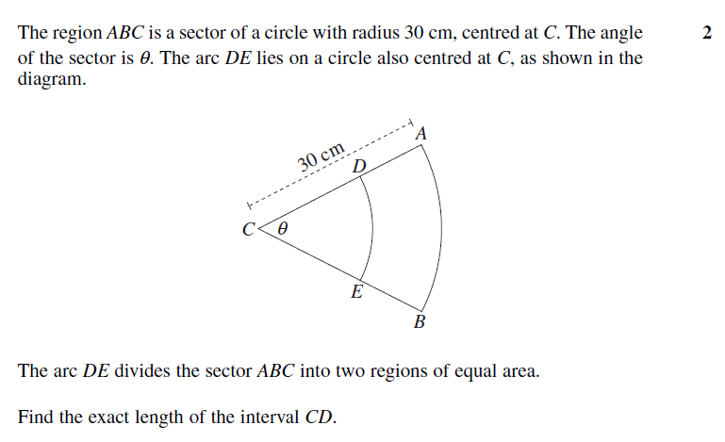

The arc DE divides the sector ABC into two regions of equal area.
Find the length of the interval CD.

Solution
$$\frac{1}{2}{\left(30-x\right)}^{2}θ=\frac{\frac{1}{2}{\left(30\right)}^{2}θ}{2}$$
$$∴\frac{1}{2}{\left(30-x\right)}^{2}=\frac{1}{4}{30}^{2}$$
$$x=8.79$$
$∴x=21.21 cm$ (15$\sqrt{2}cm)$

OR

$$\frac{1}{2}x^{2}θ=\frac{1}{4} {30}^{2}θ$$

$$x=21.21 cm$$

Specific behaviours
substitutes correctly for small sector
substitutes correctly for large sector
divides large sector by 2

Question 21 {1.2.4} (4 marks)

A ground search for a lost hiker is being organised using three camping sites in a national park as bases. It is known that the hiker is within the triangular area formed with the three campsites as vertices. Campsite A is 15km due east from campsite B. Campsite C is on a bearing of 170º from campsite A (hint : ). Campsite B is 20km from campsite C.
Note: The diagram is not to scale.

B 15 km A

20 km

C

Calculate the area of the search to the nearest square kilometre.

Question 22 (1.3.11, 1.3.13) (2, 2, 2, 2 = 8 marks)
There are 250 Year 11 students at Perth Modern School where 205 students study $Mathematics Methods, 125 study Chemistry. Also, 91 study both Mathematics Methods and$ Chemistry.

- Represent this information in a completed Venn diagram.
Solution
Specific Behaviours
Venn has a universe and 4 fields completed.
correct numbers.

- What is the probability that a student in Year 11 studies neither Mathematics Methods nor Chemistry?
Solution
$$P(\overline{M∪C})=\frac{11}{250}$$

Specific Behaviours
correct numerator
correct denominator

- Given that a student in Year 11 studies Mathematics Methods, what is the probability that they also study Chemistry?

Solution
$$P\left(M | C\right)=\frac{91}{205}$$

Specific Behaviours
correct numerator
correct denominator

- Given that a student in Year 11 studies Chemistry, what is the probability that they also study Mathematics Methods?

Solution
$$P\left(C | M\right)=\frac{91}{125}$$

Specific Behaviours
correct numerator
correct denominator

Question 23 (1.3.7, 1.3.11, 1.3.14, 1.3.16) (1, 1, 1, 1, 1, 1 = 6 marks)

- Events A and B are such that $P(A) = 0.4$, $P(B) = 0.7$ and $P(\overline{A}∩B)= 0.4$ . Determine:
- $P(A∩\overline{B})$
Solution
$$P(A∩\overline{B}) =0.1$$
Specific Behaviours
correct answer

- $P(\overline{A}∩\overline{B})$
Solution
$$P(\overline{A}∩\overline{B})=0.2$$
Specific Behaviours
correct answer

- Given $P(D) = \frac{2}{3}$ , $P\left(C | D\right)=\frac{3}{5}$ and $P\left(C | \overline{D}\right)=\frac{1}{5}$. Determine:
- $P(C∩D)$
Solution
$$P(C∩D)=\frac{2}{5}$$

Specific Behaviours
correct answer
- $P(C∩\overline{D})$
Solution
$$P(C∩\overline{D})=\frac{1}{15}$$

Specific Behaviours
correct answer
- $P(C)$
Solution
$$P(C) =\frac{7}{15}$$
Specific Behaviours
correct answer

- $P\left(\overline{D} | C\right)$
Solution
$$P\left(\overline{D} | C\right)=\frac{1}{7}$$

Specific Behaviours
correct answer

END of SECTION

Additional working space
Question number:

Additional working space
Question number:

Additional working space
Question number:

Additional working space
Question number:

